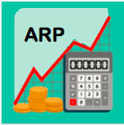
Roadmap
FY21 Adopted Budget
arp.nd.edu

getting started
- Open your Chrome browser and go to arp.nd.edu
- First time you log in, check My Settings for e-mail notifications and disable the “send back” option.
- Open 2 tabs – one for planning and one for reporting – right click on your ARP tab and select “duplicate”.
- From your Planning Control Panel, select the “FY21_Adopted_Budget” scenario.
- Expand the “Budget Hierarchy” to find your specific Budget Entity (or enter an org or name in the search box), and click on the Budget Entity in green.
- In the middle pane titled, “Template”, click on the template you want to go in to budget.
- In the right pane titled, “Templates “, click on the “input” option.

REPORT BALANCING for unrestricted funds
Before you begin your Adopted Budget planning, run report 01.
Reports -> 01 – Adopted Budget -> Unrestricted Balancing
- This report indicates what your “net” balance is at any given point in the budgeting process for each of your budget entities at the FOPA level.
After your work is complete, run reports 01 & 08.
Reports -> 08 – Adopted Budget -> All Funds Comparison
- This report helps you to compare your current year Adopted Budget to prior year trends.
When report 01 balances to a “net” $0 you are done with your unrestricted budgeting and should:
- Ensure your budget entities are in the “approved” workflow status
- Contact the Budget Office for assistance if you have 83075 adjustments that need to be made

TIP: Reports will be updated every 15 minutes for budgeting changes. If a report is already open, click “Run” to refresh the data displayed in the report.

WorkForce Planning (WFP) template
From the Roster View
- Give a Merit increase in the column titled, “Budget Review %” or “Budget Review Amount” (must first select Percent or Amount in “Budget Review In” column)
- Give an Other increase in the column titled, “Other Percent”; select an option from the column titled, “Reason Code”
Note: If giving a Merit and an Other increase to one employee, the total percentage of the two increases is entered into the “Budget Review %” column and the Other percent is entered into the “Other Percent” column. **Short Video Available**
- Change hours for an hourly employee in column titled, “Hours/Period”
Note: a PAF form still needs to be submitted to HR
- Change annual salary for vacant positions in the column titled, “Annual Salary”
- Save

From the Employee Edit View
For Lump Sums and Labor Distribution changes: Highlight the employee, click on “Employees” > “Edit”
- Apply a Lump Sum payment in July in the tab titled, “I/P Comp Items” and enter a “Reason Code” **Short Video Available** Note: an Additional Pay for Services form still needs to be submitted to HR
- Add or split the Labor Distribution in the tab titled, “Allocation” **Short Video Available**
- Save and Process

- A Reason Code is required when budgeting an “Other Increase” or a “Lump Sum” payment.
- When giving a Merit Increase and an Other Increase, the total % is entered into the “Budget Review %” column.
- Merit and Other Increases need to be entered as a %, with a max. of 2 decimal points.
- FY21 labor distributions changes need to be made in ARP.
- Vacant names can be changed and will remain as such in ARP.
- Attachments will stay in the current year Adopted Budget.
- Do not use “Notes” (they do not save in WFP; ok to use notes in all other templates).
- Remember to save employees before leaving the WFP template.

Hours Conversion Chart (for labor planning)
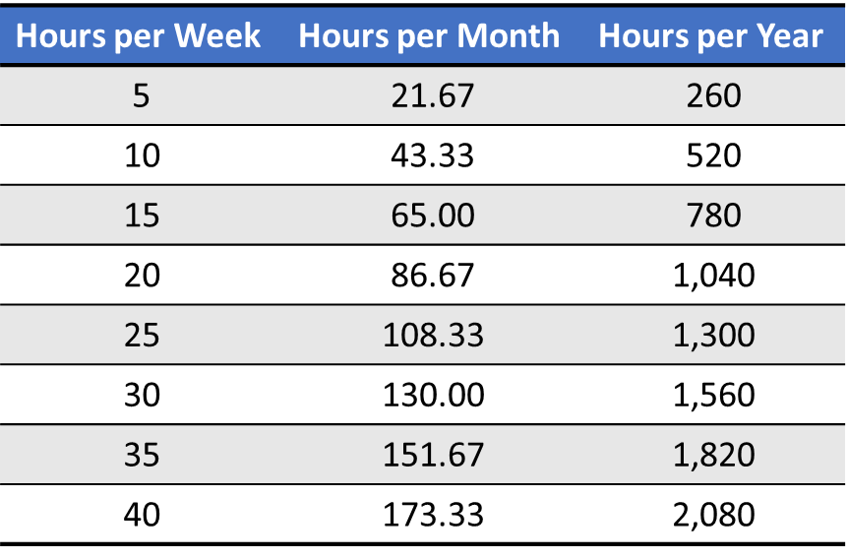

Workflorce Planning data
Data fields that can be modified in ARP and will feed to Banner for FY21:
Field Name | Single Filled Jobs | Vacant Jobs
Budget Review % (merit increase)  Budget Review Amount (merit increase) | Yes  Yes | Yes  Yes
Other Percent | Yes | Yes
Reason Code | Yes | Yes
Labor Distribution | Yes | Yes
Annual Salary | No | Yes
Position Budget Org* | No | No
*Contact Budget Office to change Position Budget Org

00 – Workflorce Planning REPORTs
Compensation Performance*
  - Labor summary with HR attributes (including Endeavor info) NOTE: This report is only available for staff
UPDATE
Labor Detail*
  - Detailed view of salary increase % and labor distribution by Employee
Labor Distribution*
  - Detailed view of all labor distribution, including shared labor
Labor Distribution to Non-Budget Entities*
  - Shows labor distributions for non-planned budget entities (i.e., not in ARP); example = agency funds
Labor Summary*
  - Summary of salary increase % by Employee
Vacancy Reports
  - Contain the salary and fringe for all vacancy and copy positions for a scenario. This report will be refreshed nightly during the Adopted Budget. Once staff WFP is locked, it will be updated approximately every 2-weeks.
WFP Compare
- Compare workforce changes between Banner and the current budget scenario. This report is updated during our refreshes approximately every 2-weeks.

TIP: Click “Run” to refresh the data displayed in a report that is already open.

*Standard Reports; updated immediately with WFP changes

Pooled labor Template
- The following data needs to be entered to budget Salaried Pooled Labor, Hourly Pooled Labor, or a Contingency: **Short Video Available**
  - Description
  - E-class
  - Start period
  - End period
  - Amount
  - Save

- Contingency dollars should be planned with a Start and End Period of 1 (of July).
- If a pooled position does not exist for what you are budgeting in this template and you would like to set one up, contact the Budget Office at position@nd.edu.

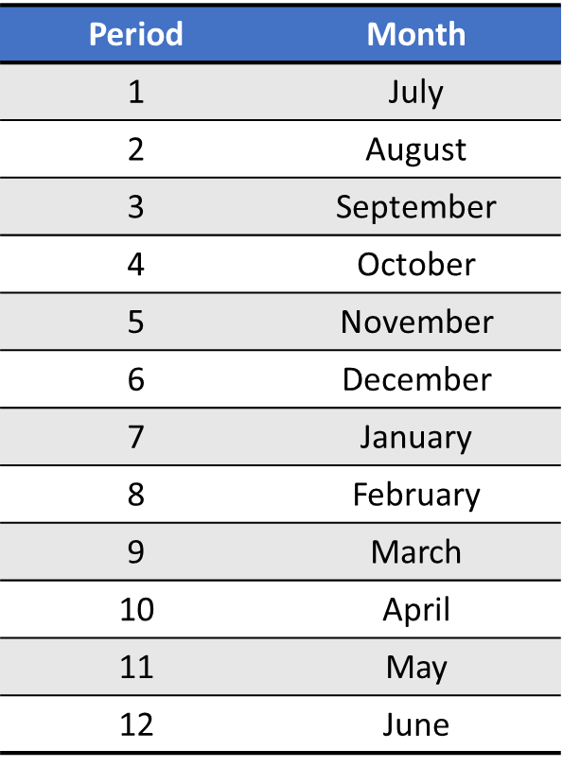
Period Conversion Chart (for labor planning)

Funds Transfer Template

- To plan a Transfer Out with a known destination: **Short Video Available**
  - Enter a description and amount in the appropriate month(s)
  - Enter F (Faculty) or S (Staff) if transfer is for a labor expense (column U)
  - Click on Mappings > Destination Account
  - Select the recipient’s
    - Fund-Org
    - Org
    - Account (81072 – Funding Transfer In)
    - Program
    - Activity (if applicable)
    - Future1 field – ‘Choose Labor-Labor’ if labor expense transfer
    - Save the destination account mapping box
  - Save the template

- To plan a Transfer Out with an unknown destination:
  - Enter a description and amount in the appropriate month(s)
    - Note: this will default to a “TBD destination”
  - Save the template
- The recipient of the transfer cannot see where it’s coming from or any notes. Best Practice is to communicate transfer detail to the recipient.
- You must enter the amount in the appropriate month(s) before mapping the destination account.
- When mapping the destination account, “type ahead” functionality is available to help populate the Fund, Org, Program, and Activity.

OpEx Unrestricted Template
NOTE: As soon as you open this template, Filter is defaulted to ‘ON’

- Non-labor Budget amounts are based on prior year monthly Adjusted Budget

- All non-labor budget changes or new budget lines must be made in the desired month (Columns AU:BF)

- To plan a Transfer In (Direct Input):
  - Enter the amount in account 81072 – Funding Transfer-In (Direct Input)
  - Click on 2021 in “Year Total(s)” column to expand the year
  - Enter transfer amount in the specific month the transfer will occur
  - A note is required indicating the source of the budgeted funding. Click on the note icon in column “L” to enter note.
  - Save the template

- To adjust the Unrestricted Allocation (83075):
  - Contact your Business Partner for assistance or to complete the adjustment for you
- A Note is required when budgeting a Direct Transfer-In
- The “83075 – Unrestricted Allocation” will always post to Period 1 (July)
- Leverage the FY20 Forecast to assess reasonableness for Beginning Fund Balances for Restricted funds
- Ctrl+E is a shortcut to download (all non-WFP) templates and reports to Excel

WORKFLOW
Preparer
- To forward multiple budgets entities (and their respective templates) for review, select the budget hierarchy Org and click “Forward All”.
Approver
- To approve and forward multiple budgets entities (and their respective templates) for final review, select the budget hierarchy Org and click “Approve”.
Note: If changes need to be made to the budget by either the Preparer or the Approver, the Approver needs to select the appropriate Budget Entity and click on the “Send Back” option.

Workflow Icons (3 bars to left of Budge Entity)
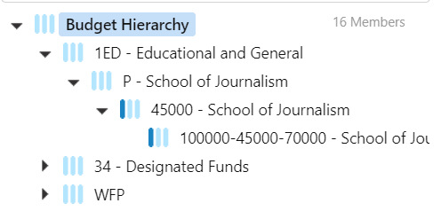
- Forwarded = 1 dark blue bar
- Approved = 2 dark blue bars
- Final Approval = 3 dark blue bars

- Users have the ability to add comments at each level of the approval process.
- When a Budget Entity is forwarded:
  - Editing is disabled in the respective templates, but you can “send back” to make changes
  - The nightly refreshes will no longer occur for that particular Budget Entity

data flow diagrams
DATA FLOW – TEMPLATES AND REPORTS
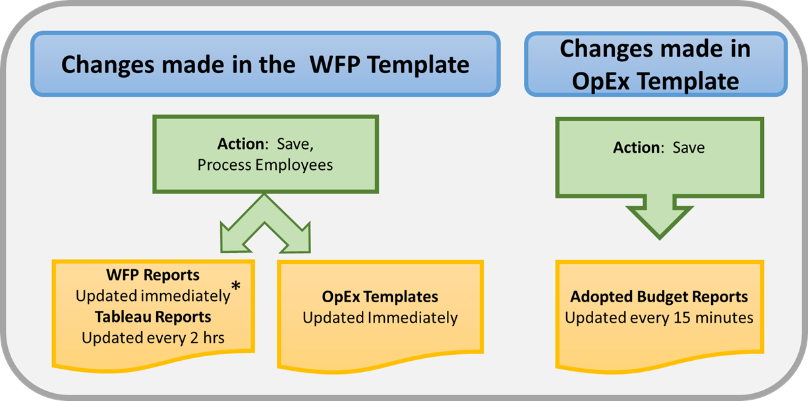
*Standard Reports only

WFP DATA FLOW – BANNER TO ARP
ARP
- Job Detail*
- New Vacant Positions
- MRR Data
- Endeavor Rating
- Position Budget Org
Nightly Refresh
BANNER HR

WFP DATA FLOW – ARP TO BANNER
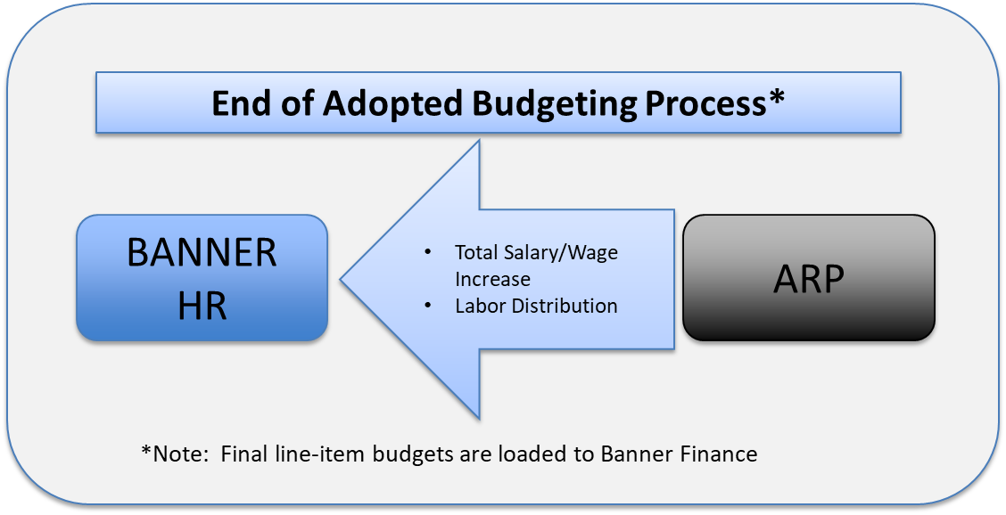

ARP RESOURCES & Support
- Budget Office Business Partner
  - List located on our website at budget.nd.edu
- Provost Office (Academic units)
- Roadmap
- Learning Portal (EPM Academy)
To access: login to ARP, click on ‘your name’ in the upper right hand corner, select ‘Help Resources’ and ‘Training’, select ‘Customer Training’ for Notre Dame specific training materials
  - Training Materials
  - ARP Short Video Series
  - Intro to ARP Video
  - End User Guide
- Open Office Hours
- ARP FUN Friday Zoom Sessions

