FY21 Adopted Budget - Reports Overview

00 - workforce planning REPORTS
Compensation Performance*
  - Labor summary with HR attributes (including Endeavor info) NOTE: This report is only available for staff
Labor Detail*
  - Detailed view of salary increase % and labor distribution by Employee
Labor Distribution*
  - Detailed view of all labor distribution, including shared labor
Labor Distribution to Non-Budget Entities*
  - Shows labor distributions for non-planned budget entities (i.e., not in ARP); example = agency funds
Labor Summary*
  - Summary of salary increase % by Employee
Vacancy Reports
  - Contain the salary and fringe for all vacancy and copy positions for a scenario. This report will be refreshed nightly during the Adopted Budget. Once staff WFP is locked, it will be updated approximately every 2-weeks.
WFP Compare
- Compare workforce changes between Banner and the current budget scenario. This report is updated during our refreshes approximately every 2-weeks.

*Standard Reports; updated immediately with WFP changes

01 - AdopTed Budget REPORTS

01 – Unrestricted Balancing
  - Shows “net” balance at any given point in the budgeting process for each of your unrestricted budget entities at the FOPA level. Shows budgeted totals for revenue, allocation, transfers, labor, non-labor, and net amounts for each budget entity.
02 – Unrestricted Balancing by Account
  - Shows “net” balance at any given point in the budgeting process for all of your unrestricted budget entities combined. Compares Allocation to Budget for All Unrestricted Funds by Account and Functional Account Type, including Net Balance.
03 – Restricted Balancing
  - Shows “net” balance at any given point in the budgeting process for each of your restricted budget entities at the FOPA level. Shows budgeted totals for beginning fund balance, revenue, transfers, labor, non-labor, and net amounts for each budget entity.
04 – Restricted Balancing by Account
- Shows “net” balance at any given point in the budgeting process for all of your restricted budget entities combined. Compares Prior Year Actuals to Budget for All Restricted Funds by Functional Account Type.
Note: All restricted funds EXCEPT for Grants & Contracts and RSPA (Fund Type 20 & 30) are included.

05 – All Funds Pooled Labor
- Compares historical spend and budget with current Adopted Budget for pooled labor for all funds.

06 – All Funds Summary
  - Includes Budget by Functional Account Type for All Funds for Single Year with Net Calculation.
07 – Restricted Fund Balances – Forecast vs Adopted
  - Compares Current Year Estimated Ending Fund Balance from Forecast to Next Year’s planned Estimated Beginning Fund Balance in the Adopted Budget. This can help you determine if the amount you are planning is reasonable.
08 – All Funds Comparison
  - Provides a high-level view of budgeting trends by comparing 3 years of historical actuals, current FY Adjusted Budget, current FY Forecast, and the future FY Adopted Budget for all funds at the account code level. This can help you determine if the amount you are planning is reasonable.
09 – Adopted Budget Detail by Month
- Provides a monthly breakout of the Adopted Budget
10 – Vacancy Report – Adopted
- Contain the salary and fringe for all vacancy and copy positions for the Adopted Scenario. This report is refreshed nightly.

Allocation Support Materials
09 – Unrestricted Summary
  - Provides a high-level walk forward of your current year allocation by account code for all of your Unrestricted Funds. The walk forward includes the FY19 Adjusted Budget, FY20 Budget Increment, and FY20 Allocation.
10 – Unrestricted Summary by Org
  - Provides same information as report “09 – Unrestricted Summary” but details is at the individual Orgs level.
11 – E&G Labor Allocation Summary
  - Provides a high-level walk forward of total salary and fringe by Org. for Unrestricted funds. The walk forward includes the FY19 Adjusted Budget, FY20 Budget Increment, and FY20 Allocation.

12 – Labor Allocation by Position
  - Provides a detailed walk forward of salary and fringe by position. The walk forward includes the FY19 Adjusted Budget, FY20 Allocation and the difference (or increment).
13 – BWG Add-on Summary
- Provides a distributed breakdown of the FY21 BWG add-ons.

To access WFP Reports:

Log-in to ARP Reports File Cabinet 00 – Workforce Planning
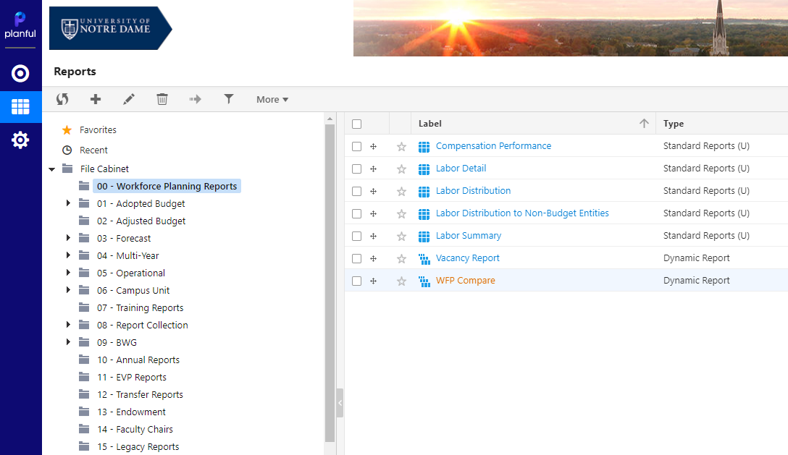

Sample Screenshots:

Compensation Performance
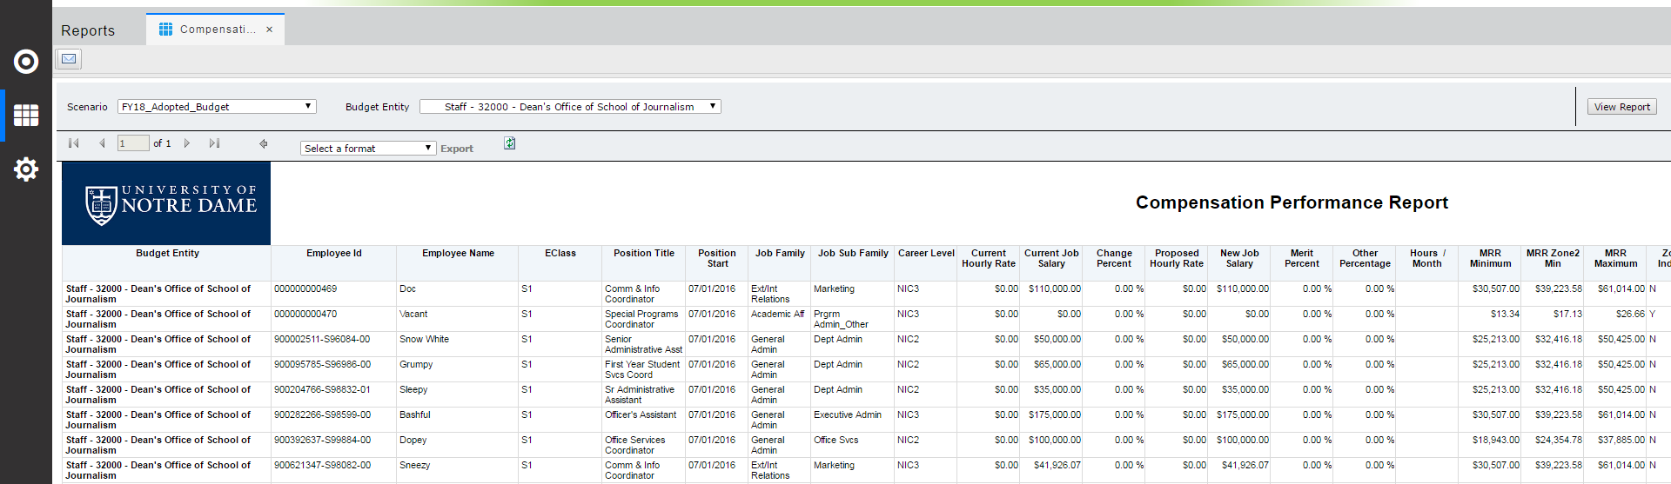

Labor Detail
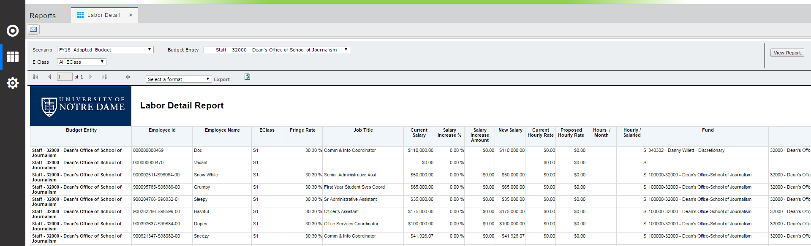

Labor Distribution
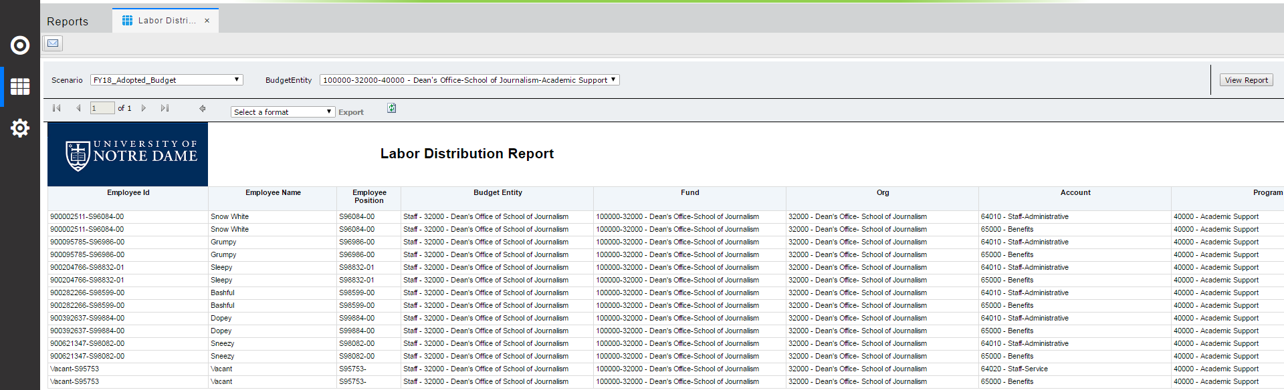

Labor Distribution to Non-Budget Entity

Labor Summary
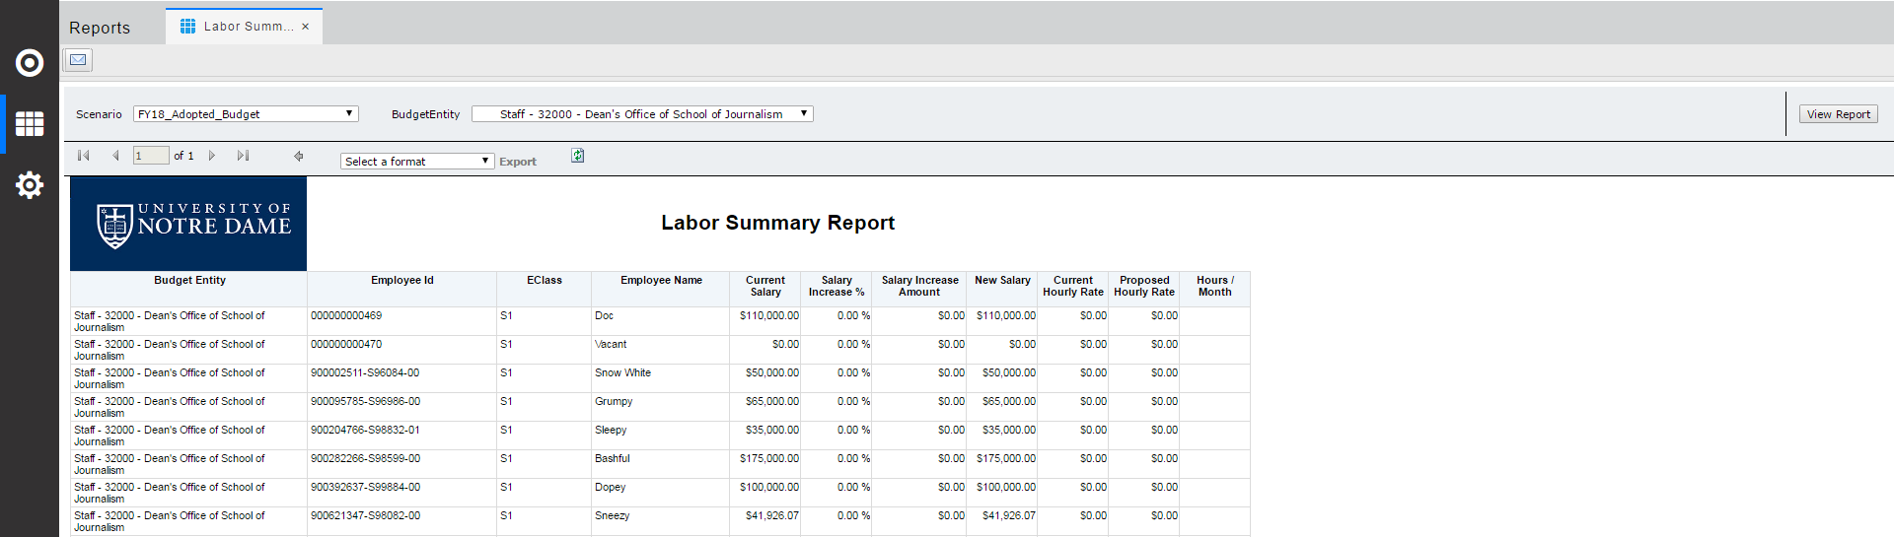

Vacancy Reports
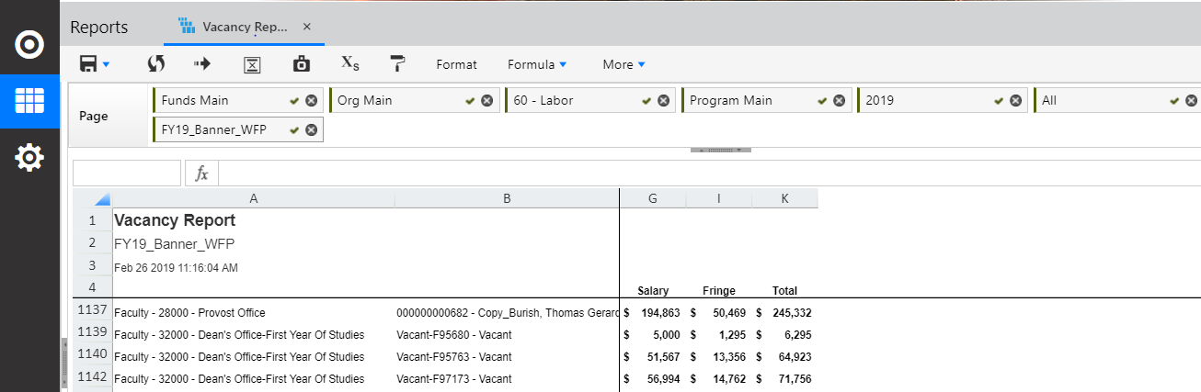

WFP Compare
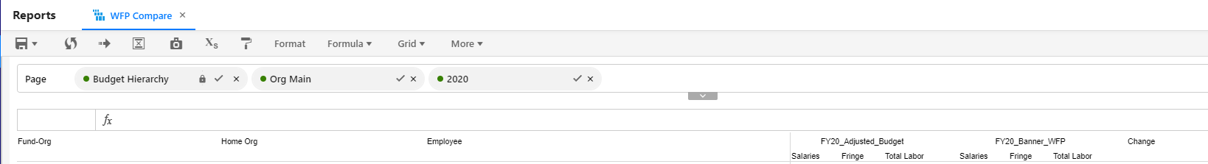

To access Adopted Budget Reports:
Log-in to ARP Reports File Cabinet 01 – Adopted Budget

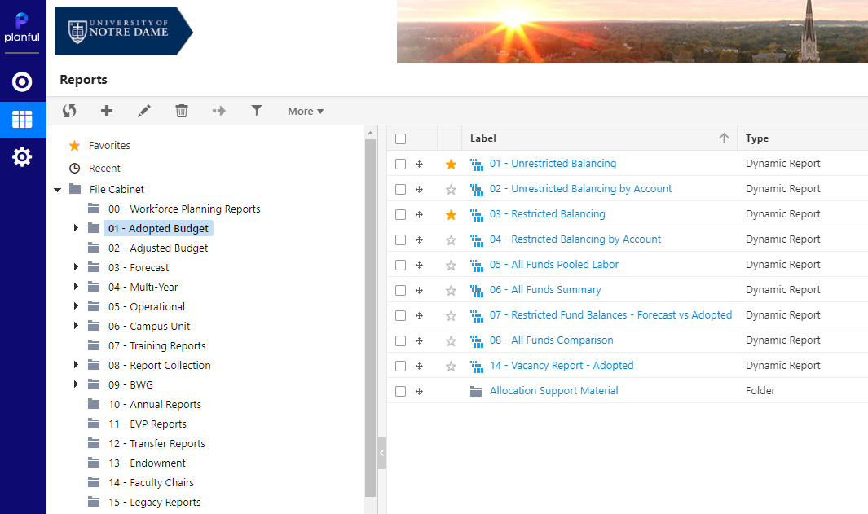

Sample Screenshots:

- Unrestricted Balancing

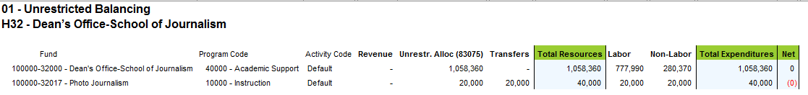

- Unrestricted Balancing by Account
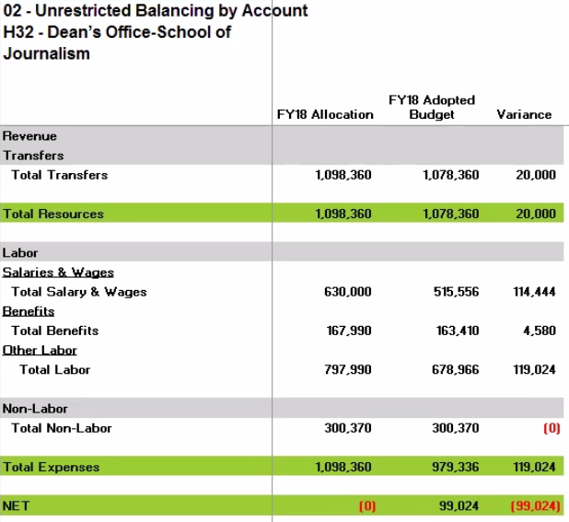

- Restricted Balancing
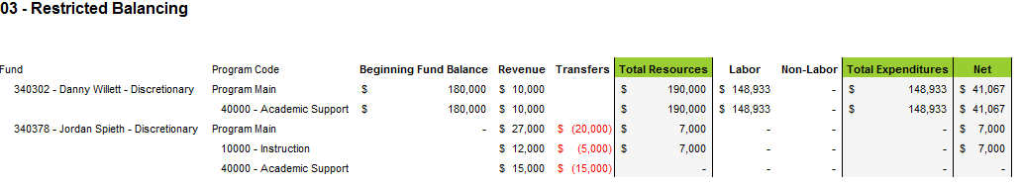

- Restricted Balancing by Account
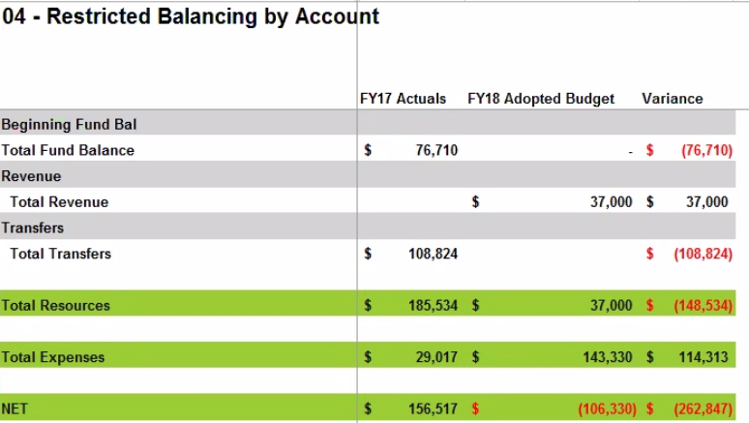

- All Funds Pooled Labor
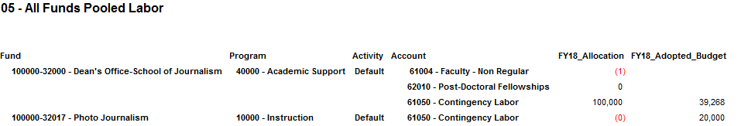

- All Funds Summary
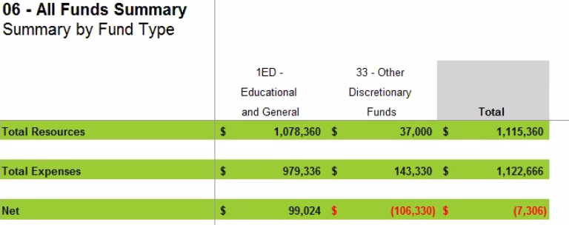

- Restricted Fund Balances – Forecast vs Adopted
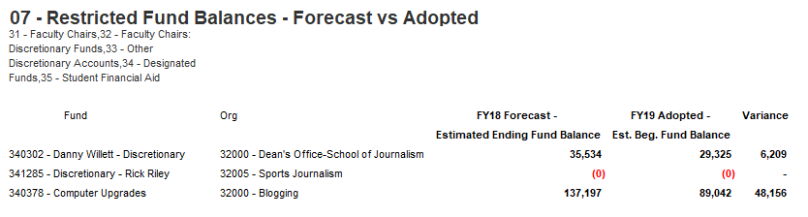

- All Funds Comparison
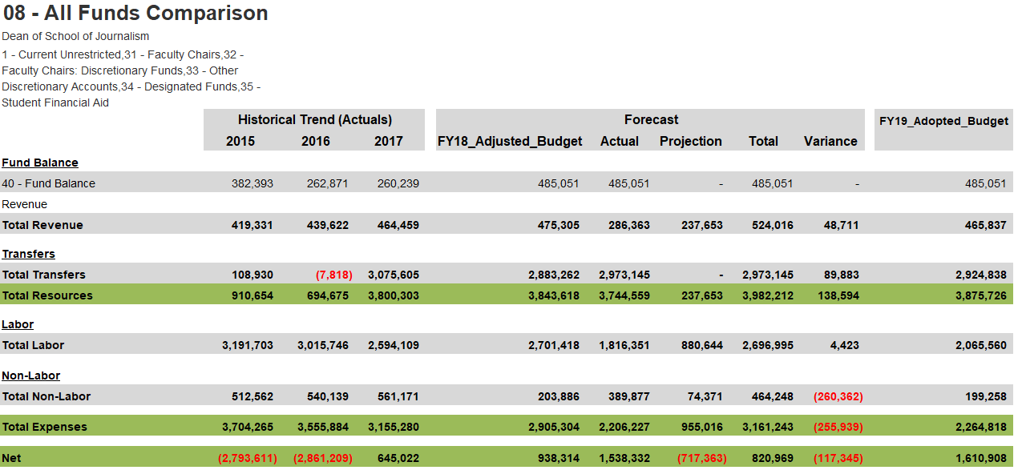

- Adopted Budget Detail by Month

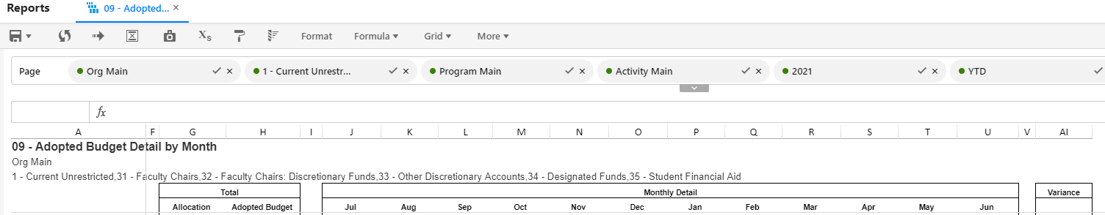

10. Vacancy Report - Adopted

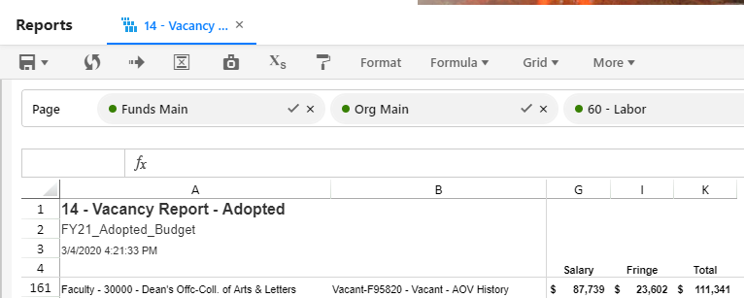

To access Allocation Support Materials:

Log-in to ARP Reports File Cabinet 01 – Adopted Budget Allocation Support Material
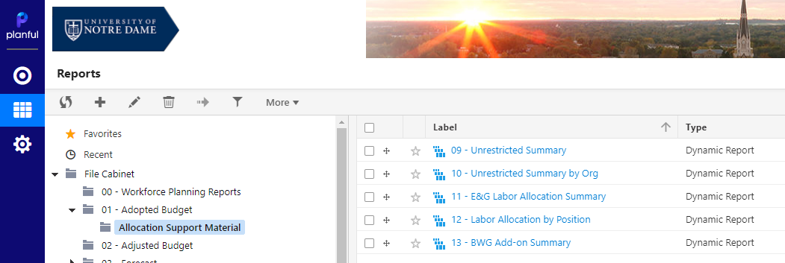

Sample Screenshots:
9. Unrestricted Summary
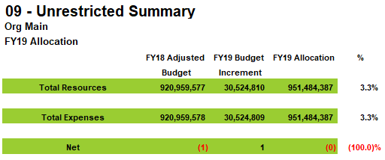
- Unrestricted Summary by Org
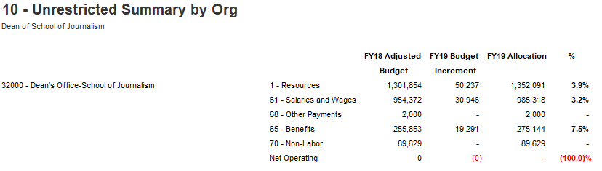
- E&G Labor Allocation Summary
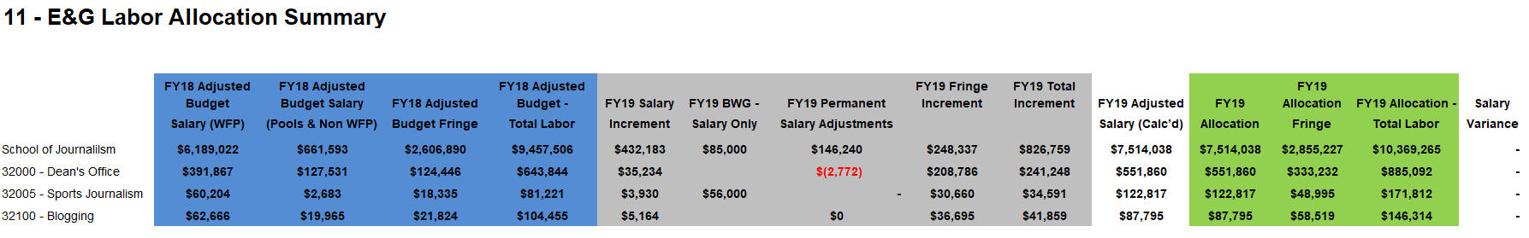

- Labor Allocation by Position
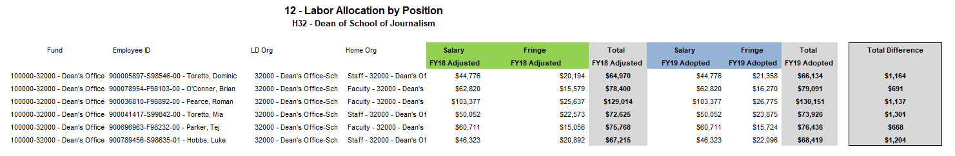

- BWG Add-on Summary
